Training Manual for
Research Tracking and Thesis Management System.
Student Login

Pre-Requisites:
- Student must have completed 9 credit hours.
- Minimum CGPA should be 3.0 or above.
- Email address should be updated in student profile.
- Student signatures should be updated in the system.

Student Login:
- Open the Internet Explorer or any other browser compatible for QALAM.
- Enter URL http://Qalam.nust.edu.pk/
- Login screen displays when you enter correct URL.

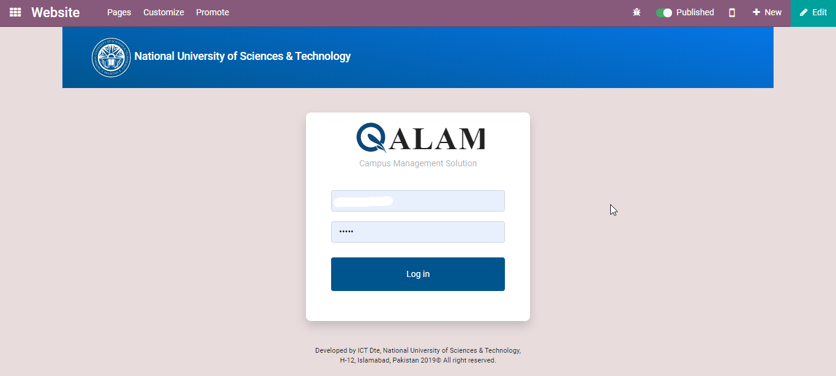
- Click on the MS Thesis Tab from the menu.
- Click on the Submit to Exam Branch button.
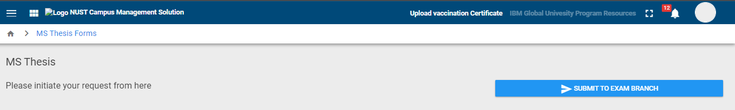
- Request Forwarded to School exam branch controller for Goaehad.
- School Exam Branch will verify the academic records and Give Go ahead for processing of Thesis.
- Once approval is done by the School Exam branch a notification is sent to the Student.
- Now Thesis form is available which is consisting the Values “TH-1 Annex A, B.
- Fill out all the details like (Selection of the supervisor, Co Supervisor, GEC Members and External GEC Member) as shown in below image.
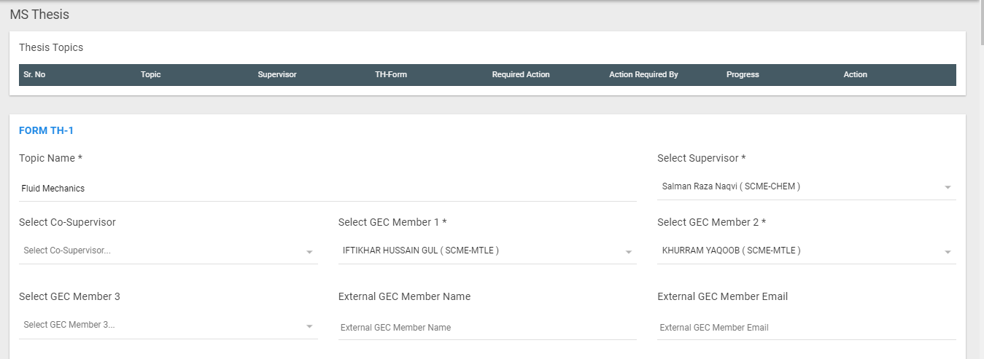

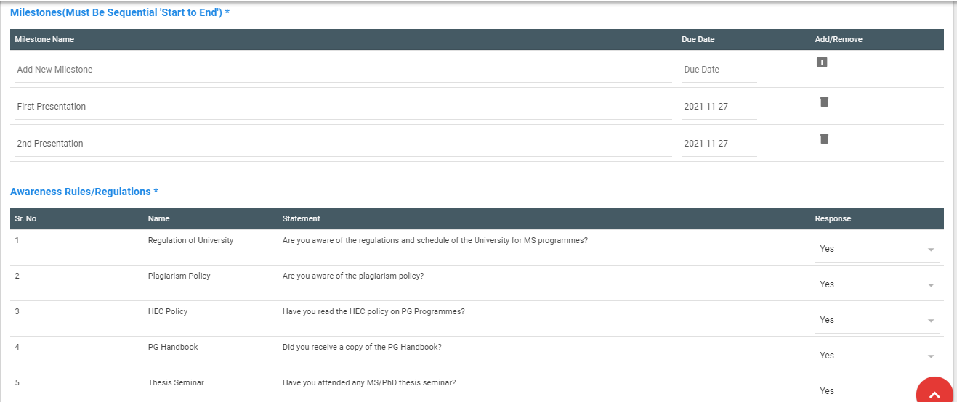

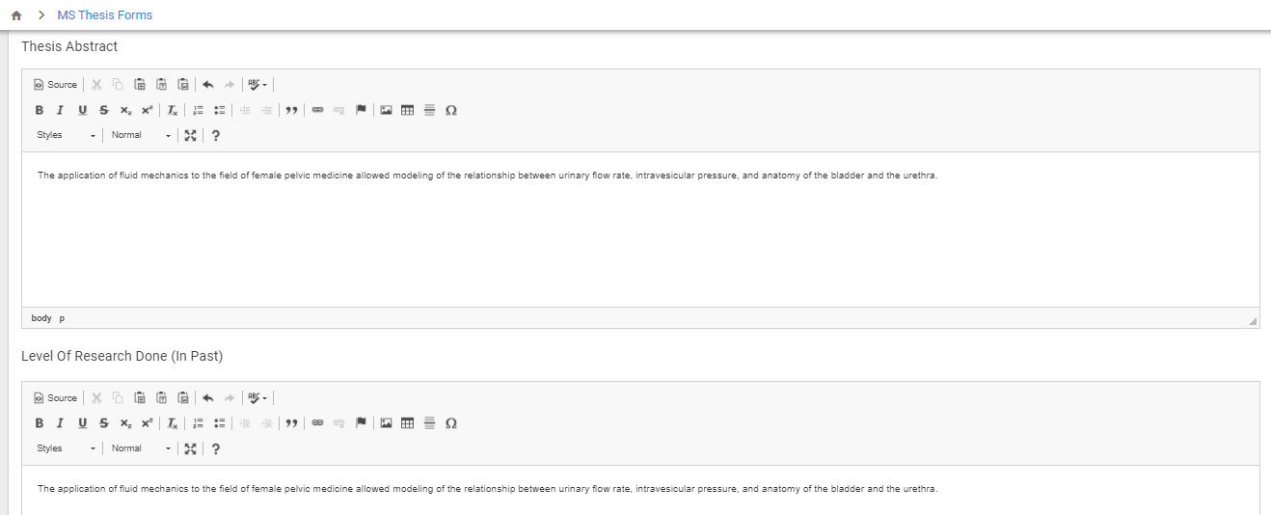

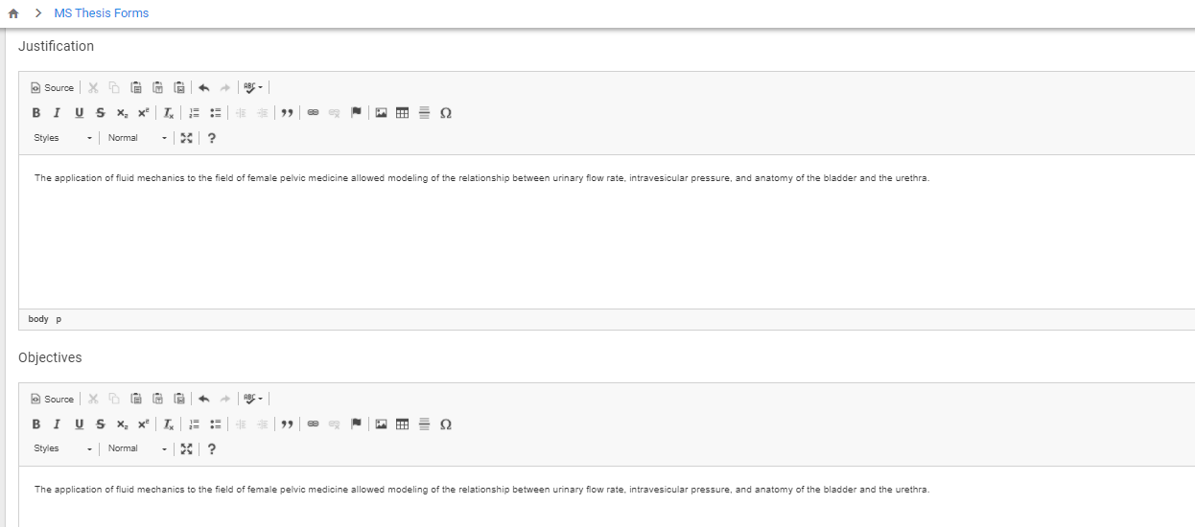
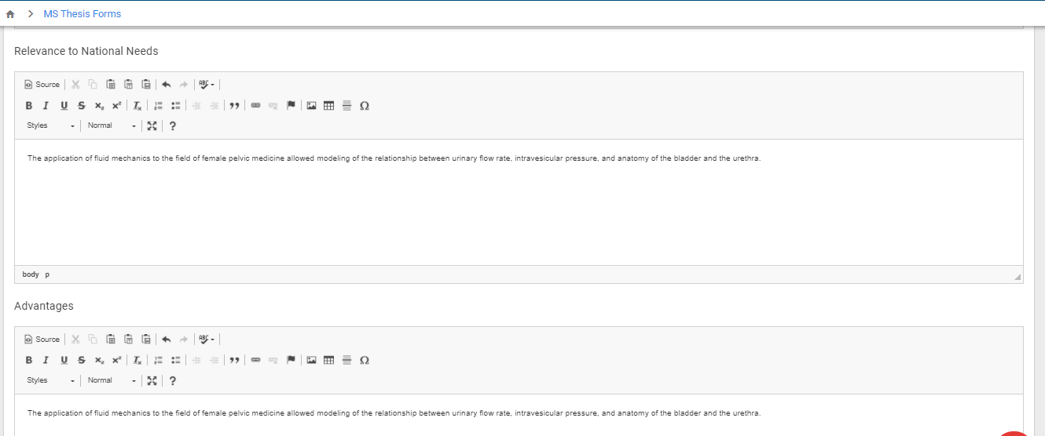
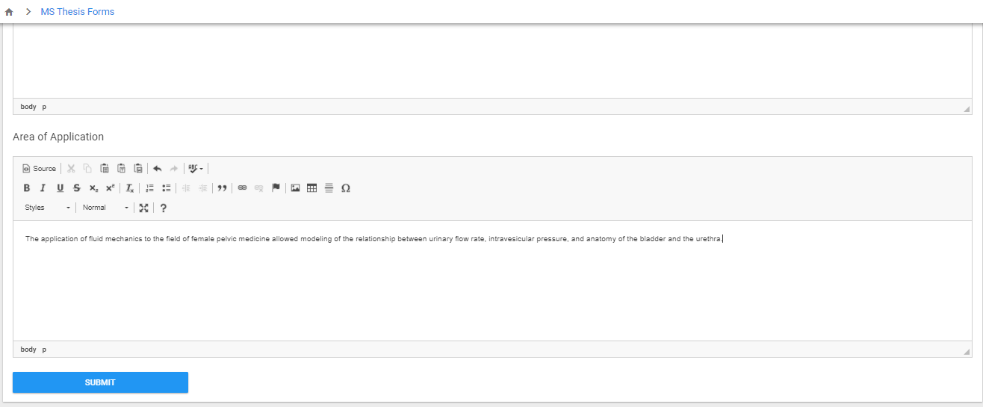
- After entering the all values click on the submit button.
- Now Request is forwarded to the Main supervisor.
- If supervisor wants to make any changes in it he may send back to the student.
- Student may update changes and submit again.
- Once Form is forwarded for the GEC Consent and approved by the HoD/Dean Th-1 will be raised.

